**Module: R2: Intro to RISC-V Assembly**

**Section:** CALL **Task:** Spike Installation

**Activity**

**Spike Installation**

**1: Running a Simple C Program:**

* + **Code Snippet:**

#include<stdio.h>

int main()

{ int x,y;

printf("Enter two Numbers (x, y):\n");

scanf("%d\n", &x);

printf("\n");

scanf("%d", &y);

int sum = 0;

sum = x + y;

printf("Sum of x and y is: %d\n", sum);

return 0;

}

‭Compiling the **main.c** file to create a relocatable object file which will then pass to the‬

‭linker in the later stage.

riscv64-unknown-elf-gcc -c main.c -o main.o

‭Now, creating the final executable by linking this relocatable object file **main.o** and other‬ ‭necessary standard library files. (It produces a binary executable with .out extension).

riscv64-unknown-elf-gcc -c main.c -o main.o

Now, running the executable using spike

spike pk ./a .out

**Terminal Output:**

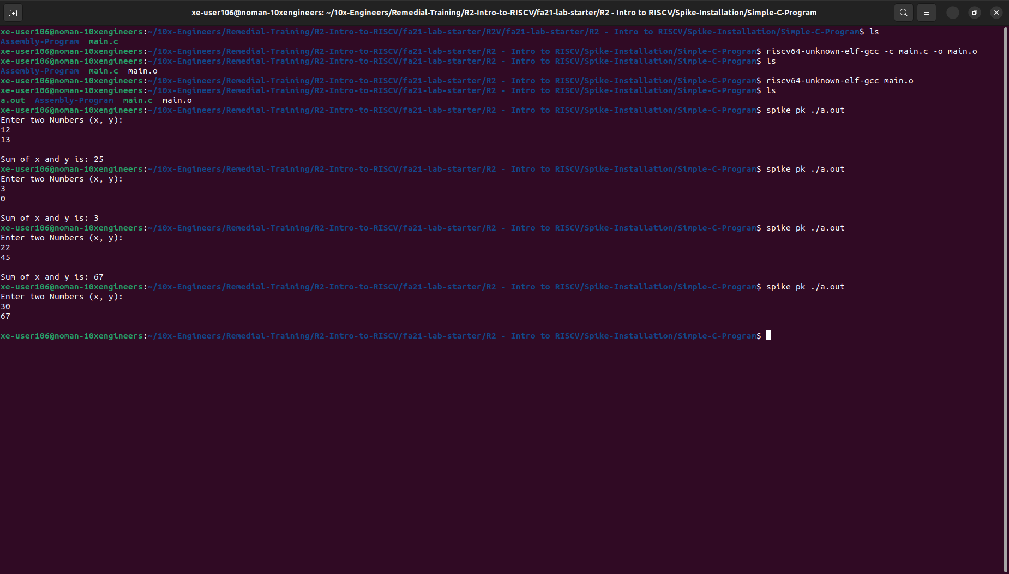

**2: Running RISCV Assembly on Spike:**

Downloaded Linked and other header files in the directory and run the assembly‬ ‭program:‬

r‭iscv64-unknown-elf-gcc -march=rv64gc -mabi=lp64 -nostdlib -T link.ld test.S -o‬ test.elf

‭Run the following command to see the dis-assembly file:

riscv64-unknown-elf-objdump -d test.elf

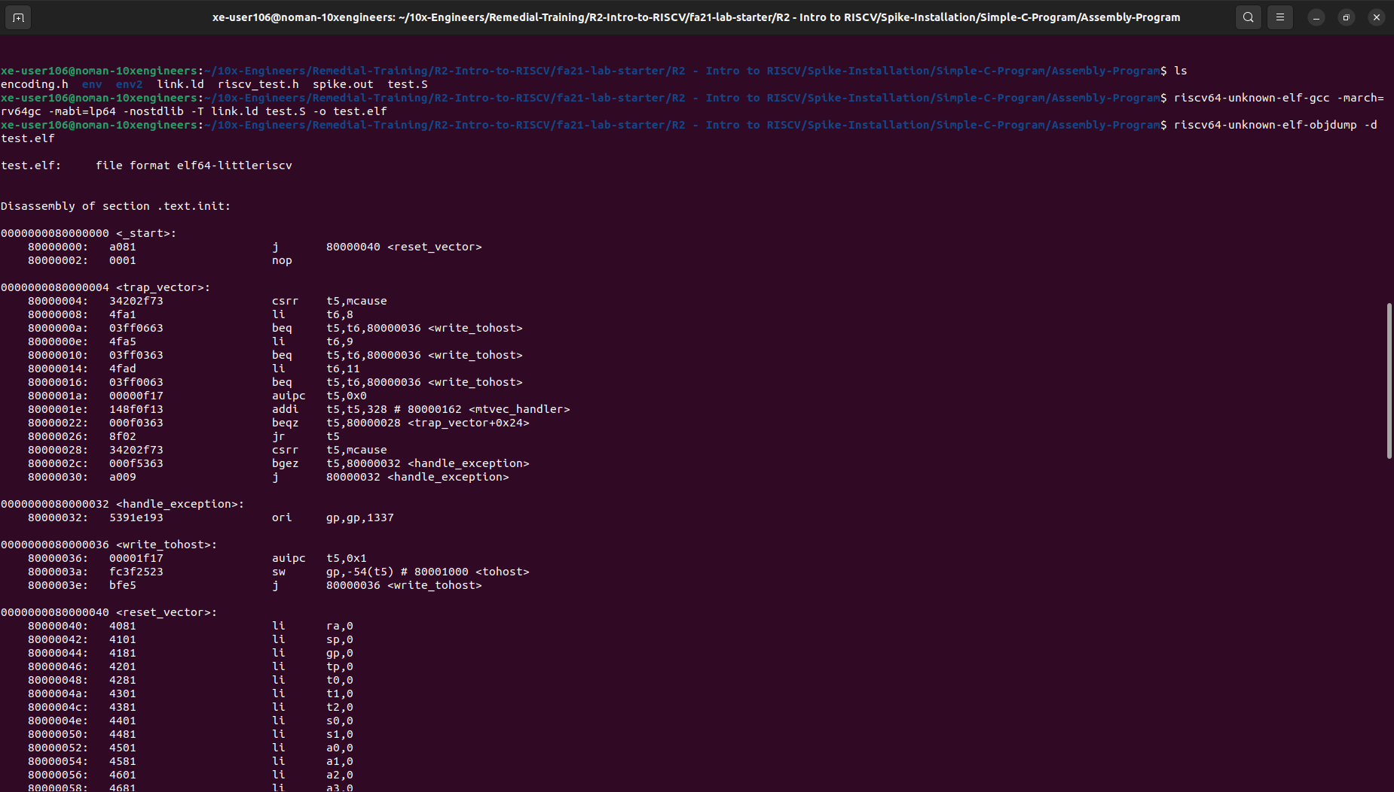

Run the following command to see the get the spike.log to see how the instructions were executed and learn about the contents of the registers:

spike --isa=RV64IMAFDC -l --log-commits test.elf 1>spike.out 2>spike.log

**spike.log:**

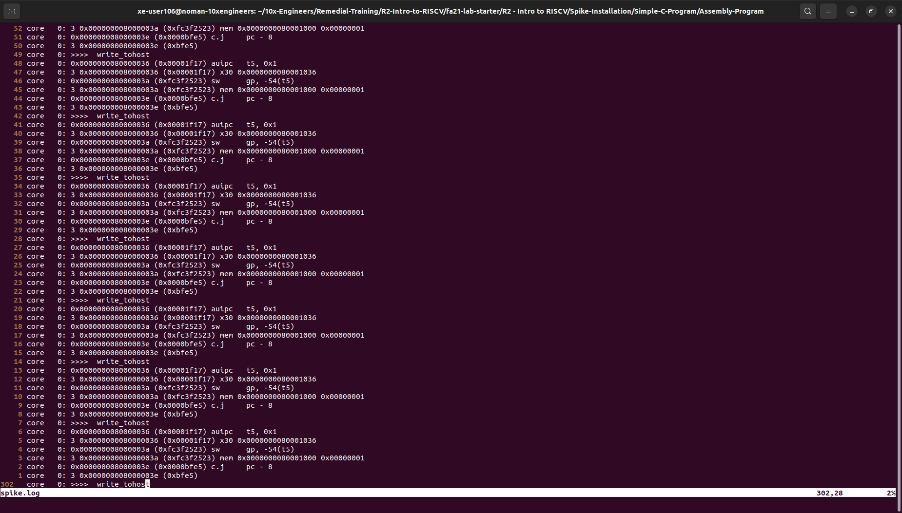

**3 . Running Risc-V Assembly programs compatible to RiscOf on spike:‬**

‭Downloaded the files from the given link and pasted in my **Assembly-Program/** folder. Now, run this‬ ‭command:

riscv64-unknown-elf-gcc -march=rv64izicsr -static -mcmodel=medany -fvisibility=hidden -nostdlib -nostartfiles -T ~/10x-Engineers/Remedial-Training/R2-Intro-to-RISCV/fa21-lab-starter/R2\ -\ Intro\ to\ RISCV/Spike-Installation/Simple-C-Program/Assembly-Program/link.ld -I ~/10x-Engineers/Remedial-Training/R2-Intro-to-RISCV/fa21-lab-starter/R2\ -\ Intro\ to\ RISCV/Spike-Installation/Simple-C-Program/Assembly-Program/env/ -I ~/10x-Engineers/Remedial-Training/R2-Intro-to-RISCV/fa21-lab-starter/R2\ -\ Intro\ to\ RISCV/Spike-Installation/Simple-C-Program/Assembly-Program/env2/ -mabi=lp64 test.S -o my.elf -Drvtest_mtrap_routine=True -DTEST_CASE_1=True -DXLEN=64

Run the following command to see the dis-assembly file:

Riscv64-unknown-elf-objdump -d my.elf

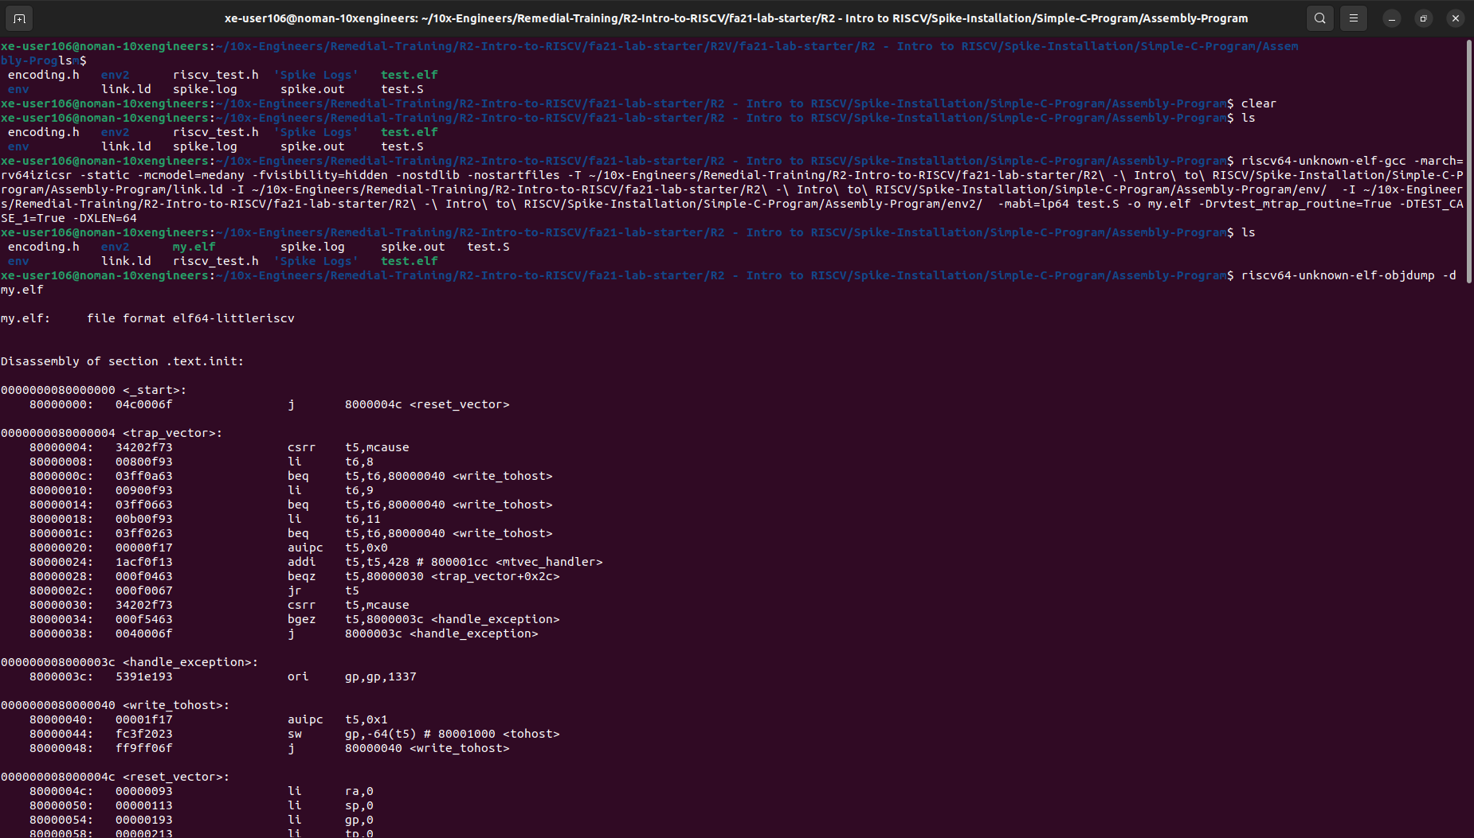

Run the following command to see the get the spike.log to see how the instructions were executed and learn about the contents of the registers:

spike --isa=RV64IMAFDC -l --log-commits my.elf 1>spike.out 2>spike.log

